A Project Proposal On
DEALMATE: A SECOND-HAND MARKET PLACE POWERED BY AI



Submitted in the Partial Fulfillment of the
Requirements for the Degree of Bachelor of Computer Engineering
Awarded by Pokhara University

Submitted By:
Krishna Kumar Gupta (21075567)
Karan Gupta (21075565)
Mahendra Saud (21075569)
Priti Paudel (21075575)

School of Engineering
Faculty of Science and Technology
Pokhara University
November 2025

ABSTRACT
Dealmate is an AI-powered, web-based consumer-to-consumer (C2C) marketplace designed to simplify the exchange of secondhand products through a secure, intelligent, and user-friendly platform. The system enables users to post listings, browse products, communicate through real-time chat, and negotiate prices with ease. Built using modern web technologies such as React.js, Node.js, Express.js, and MongoDB Atlas, the platform ensures smooth performance, data reliability, and an efficient user experience. Dealmate integrates advanced Artificial Intelligence features powered by Gemini (gemini-1.5-flash), including automated product category prediction, image understanding, and AI-generated product descriptions. Additionally, local machine learning models using scikit-learn provide personalized product recommendations, while spaCy performs sentiment analysis on user reviews. Overall, this project demonstrates the practical application of AI-enhanced web technologies to improve listing quality, increase user trust, and promote sustainable reuse through an secondhand-marketplace.
Key Words: C2C, Marketplace, E-commerce, Web Application, Product Exchange

TABLE OF CONTENTS
ABSTRACT i
TABLE OF CONTENTS ii
LIST OF FIGURES iv
LIST OF TABLES v
ABBREVIATIONS vi
CHAPTER 1 1
INTRODUCTION 1
1.1 Background 1
1.2 Problem Statement 1
1.3 Objectives 1
1.4 Applications 1
1.5 Project Features 2
1.6 Feasibility Analysis 2
1.6.1 Economic Feasibility 2
1.6.2 Technical Feasibility 3
1.6.3 Operational Feasibility 3
1.7 System Requirement 3
1.7.1 Software Requirement 3
1.7.2 Hardware Requirement 4
CHAPTER 2 5
LITERATURE REVIEW 5
2.1 Introduction 5
2.2 The Evolution and Inherent Challenges of C2C Marketplaces 5
2.3 Artificial Intelligence as a Catalytic in E-Commerce 5
2.4 Leveraging Computer Vision for Listing Automation 6
2.5 The Centrality of Trust and Security 6
2.6 Synthesis and Identified Research Gap 6
2.7 Proposed System Framework 7
CHAPTER 3 8
METHODOLOGY 8
3.1 Software Development Life Cycle 8
3.2 Waterfall Model in Software Development 8
3.2.1 Analysis Phase 9
3.2.2 Design Phase 9
3.2.3 Coding Phase 9
3.2.4 Testing Phase 10
3.2.5 Deployment Phase 10
3.2.6 Maintenance Phase 10
3.3 ER Diagram 11
3.4 Flowchart 12
3.5 Use Case Diagram 13
3.6 Working Principle 14
CHAPTER 4 16
EPILOGUE 16
4.1 Expected Output 16
4.2 Budget Analysis 16
4.3 Work Schedule 17
REFERENCES 18

LIST OF FIGURES
Figure 3.1: Waterfall Model 8
Figure 3.2: ER Diagram 11
Figure 3.3: Flowchart 12
Figure 3.4: Use Case Diagram 13
Figure 4.1: Gantt Chart 17

LIST OF TABLES
Table 1.1: Software Requirement for Dealmate 3
Table 1.2: Hardware Requirement for Dealmate 4
Table 4.1: Budget Analysis 16

ABBREVIATIONS

AI | Artificial Intelligence
API | Application Programming Interface
C2C | Consumer to Consumer
CSS | Cascading Style Sheets
ER | Entity Relation
IDE | Integrated Development Environment
JSON | JavaScript Object Notation
SDLC | Software Development Life Cycle
UI | User Interface
VS Code | Visual Studio Code

CHAPTER 1

INTRODUCTION

Background
Nowadays, the network plays an important role in people’s life. In the digital age, online marketplaces have transformed the way people buy and sell goods. Traditional methods of advertisement and trade have become inefficient compared to fast, secure, and location-based platforms. Our project Dealmate serves as a local digital marketplace that connects buyers and sellers directly, allowing them to trade second-hand goods efficiently and transparently. The platform focuses on usability, security, and convenience while promoting sustainability through reuse of resources.

Problem Statement
People often face challenges in selling or buying used products due to the absence of a centralized, trustworthy, and easy-to-use local trading platform. Social media groups and offline markets lack security, product categorization, and credibility. Thus, there is a need for a reliable digital system that connects verified users for transparent and efficient second-hand trading.

Objectives
The main objectives of this project are as follows:
- Secondhand Marketplace with AI-based auto descriptions, product categorization, recommendations.
- Seamless buying and selling with AI chat support for easy user interaction.

Applications
Dealmate can be used for local and regional trading of products like electronics, furniture, books, and more. It also supports students and general users for easy product exchange. Businesses can use it for resale and clearance sales, while also promoting a sustainable circular economy through product reuse and waste reduction.

Project Features
Dealmate is designed as an intelligent marketplace where advanced AI features are natively integrated into the core user experience to enhance usability, efficiency, and trust. The key features of the platform are:
- User Authentication & Support System: Secure user registration and login, supported by an intelligent AI-powered chatbot for instant query resolution and user guidance.
- AI-Enhanced Product Listing Management: A streamlined interface for posting, editing, and managing products, augmented with AI for automatic category prediction and dynamic product description generation using the Gemini API.
- Advanced Search & Personalized Discovery: Smart filtering by category, price, condition, and location, combined with a personalized product recommendation engine powered by scikit-learn to surface relevant items for each user.
- Intelligent Communication & Trust Building: An integrated real-time chat for direct buyer-seller negotiation and a transparent review system that utilizes spaCy for sentiment analysis to provide deeper insights into user feedback and seller performance.
- Comprehensive Administration & Moderation: A dedicated admin panel for overseeing users, listings, reports, and platform analytics, ensuring smooth and secure platform operations.

Feasibility Analysis
For the development of our website “Dealmate” we went through three type of feasibility studies.

Economic Feasibility
Our Economic feasibility evaluates the cost-effectiveness of the project by comparing the expected benefits with the required expenses. Dealmate is economically feasible as it uses open-source technologies and low-cost hosting, reducing overall expenses. The estimated development and maintenance costs are justified by the expected benefits, including increased revenue potential, user engagement and improved customer satisfaction.

Technical Feasibility
The technical feasibility of the Dealmate was evaluated by assessing the technical resources and capabilities required to develop and maintain the system. We determined that the required technical resources, such as hardware and software, were readily available and that the development team had the necessary technical skills and experience.

Operational Feasibility
Dealmate is operationally feasible as it provides a simple and intuitive interface that users can easily understand and navigate. The integrated AI chatbot offers real-time assistance, ensuring smooth onboarding and minimal learning effort for new users. The system’s responsive design and reliable performance make it suitable for both web and mobile users in real-world scenarios.

System Requirement
The system requires a combination of software and hardware components to function efficiently. Since Dealmate is designed as a web-based platform with AI integration, it does not require high-end hardware for basic operation. However, development, hosting, and AI processing require certain minimum specifications.

Software Requirement
Table 1.1: Software Requirement for Dealmate
Software Tool | Specification
React.js | Frontend library for building the user interface.
Node.js | JavaScript runtime for backend development.
Express.js | Web application framework for Node.js.
MongoDB Atlas | Cloud-based database for storing application data.
Python | Programming language for developing AI models and services.
Flask | Micro web framework for creating Python-based AI APIs.
Google Gemini API | Cloud AI service for image understanding, category prediction, and description generation.
scikit-learn | Machine learning library for building the recommendation system.
spaCy | NLP library for performing sentiment analysis on reviews.
Git | Version control for tracking code changes and collaboration.
GitHub | Platform for hosting the code repository and project management.
Visual Studio Code | Primary Integrated Development Environment (IDE) for coding.

Hardware Requirement
Table 1.2: Hardware Requirement for Dealmate
Hardware Component | Specification
Development Machine | Laptop/Desktop with Intel i5 processor or equivalent, 8GB RAM (16GB recommended), and 256GB storage.
Testing Devices | Multiple devices with different screen sizes (desktop, tablet, mobile) for cross-browser and responsive testing.
Internet Connection | Stable broadband connection for development, testing, and accessing cloud services.

CHAPTER 2

LITERATURE REVIEW

Introduction
This chapter critically reviews existing scholarly works and technologies pertaining to online marketplaces, the second-hand product economy, and the application of Artificial Intelligence (AI) in e-commerce. The purpose is to establish a robust theoretical foundation for the Dealmate project and to identify specific, evidence-based gaps in current C2C platforms that justify the development of an intelligent, AI-enhanced solution.

The Evolution and Inherent Challenges of C2C Marketplaces
Online marketplaces have fundamentally transformed commerce by digitizing transactions. Laudon & Traver [3] emphasize their core benefits: unparalleled convenience, 24/7 availability, and access to a global audience. C2C platforms like OLX and Facebook Marketplace leverage this model to enable direct trade between individuals. However, their simplistic approach often reproduces the inefficiencies of physical markets in a digital space. Empirical research by Kim et al. [9] specifically identified critical shortcomings in second-hand platforms, including inconsistent and poor product categorization, over-reliance on basic keyword-based search, and a general lack of personalized recommend-ation. These deficiencies lead directly to user frustration, inefficient product discovery, and reduced platform engagement, creating a clear demand for more intelligent systems.

Artificial Intelligence as a Catalyst in E-commerce
AI has emerged as a key differentiator in modern e-commerce, moving beyond automation to providing personalized and predictive services. Huang & Rust [10] theorize a framework where AI progressively enhances service capabilities from mechanical to analytical to intuitive. In practical terms, Chen et al. [11] provided empirical evidence that AI-driven recommendation systems significantly boost conversion rates, user engagement, and customer retention. For C2C marketplaces, the applications are multifaceted:
- Automated Product Classification: Reducing manual entry errors and ensuring consistent data organization.
- Intelligent Recommendation Engines: Using techniques like Content-Based and Collaborative Filtering to curate personalized product listings for users [12].
- Fraud and Risk Mitigation: Analysing user behaviour patterns to identify and flag potentially fraudulent activities.
The proven success of these AI applications in structured B2C environments provides a strong, transferrable rationale for their integration into the more dynamic and trust-dependent C2C model.

Leveraging Computer Vision for Listing Automation
A significant bottleneck in C2C platforms is the reliance on sellers, who may lack marketing expertise, to create accurate and compelling listings. AI-powered computer vision directly addresses this challenge. Wang et al. [12] demonstrated the efficacy of Convolutional Neural Networks (CNNs) in automatically classifying products from images, thereby minimizing human error and inconsistency in categorization. This technology forms the foundational evidence for Dealmate's objective to use the Gemini API for automated category prediction and feature extraction, streamlining the entire listing process.

The Centrality of Trust and Security
Trust remains the most significant barrier to transaction completion in C2C environments. Pavlou [12] empirically established that a user's perceived risk and lack of trust directly negatively impact their intention to transact online. Modern platforms combat this through layered technological and design strategies. Beyond traditional rating systems [13], AI is now deployed for proactive trust and safety, analyzing behavioral data to detect fake accounts and suspicious listing patterns. This literature underscores the necessity for Dealmate to incorporate not only a transparent review system but also underlying AI mechanisms that contribute to a safer ecosystem.

Synthesis and Identified Research Gap
The comprehensive review of existing literature reveals a consistent pattern in the evolution of C2C marketplaces. While platforms have successfully transitioned traditional trading to digital spaces, offering unprecedented accessibility and reach as noted by Laudon & Traver [3], they predominantly function as basic digital bulletin boards. These platforms rely almost entirely on user-generated content with minimal intelligent intermediation. The empirical research by Kim et al. [9] critically highlights the consequences of this approach, documenting systemic shortcomings such as inconsistent product categorization, ineffective search mechanisms reliant on basic keyword matching, and a complete absence of personalized discovery tools for users. These are not superficial issues but fundamental architectural flaws that directly lead to user frustration, inefficient market matching, and ultimately, stunted platform growth and engagement.
Simultaneously, the literature on Artificial Intelligence in commerce, including the strategic framework proposed by Huang & Rust [10] and the empirical validations by Chen et al. [11], provides compelling evidence of AI's capacity to solve these exact problems. Research demonstrates that AI can automate complex classification tasks, personalize user experiences at scale, and derive deeper insights from unstructured data.

Proposed System Framework
The Dealmate system is engineered to deliver specific capabilities that directly address the limitations of existing platforms. The key outputs of the system are:
- Automated Listing Generation: The system processes user-uploaded product images through the Gemini API to output predicted product categories, generated titles, and a structured list of key features, thereby creating a comprehensive listing draft automatically.
- Personalized Recommendation Feed: Based on product features and user interactions, the system's scikit-learn engine outputs a dynamically generated list of recommended products for each user, personalizing the browsing experience and improving item discoverability.
- Analytical Trust Metrics: Beyond simple ratings, the system outputs a sentiment analysis score for textual reviews using spaCy, providing an additional, data-driven layer to evaluate seller credibility and transaction satisfaction.

CHAPTER 3

METHODOLOGY

Software Development Life Cycle
The development of Dealmate follows the Waterfall Model of the Software Development Life Cycle (SDLC). This linear and sequential approach was chosen due to its structured nature, which is well-suited for a project with clearly defined requirements and stable objectives from the outset. The model ensures that each phase—Requirements Analysis, System Design, Implementation, Testing, Deployment, and Maintenance—is fully completed before the next phase begins, providing clear milestones and thorough documentation at every stage.

Waterfall Model in Software Development
The Waterfall Model is a linear software development approach where each phase is completed in sequence. For Dealmate, we first collected and finalized all requirements for features like product listing, AI prediction, and chat. After that, the system design, including UI, database, and architecture, was prepared. The development team then implemented all modules and tested the complete platform for functionality and errors.
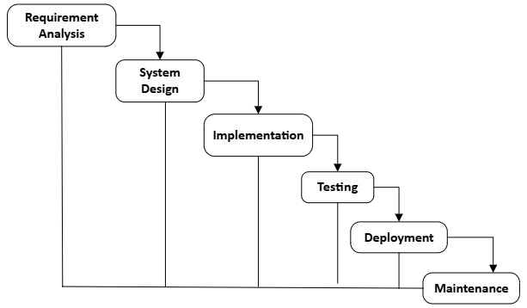Figure 3.1: Waterfall model for Dealmate

Analysis Phase
In this phase, all the requirements for developing Dealmate are identified, analyzed, and documented. The team gathers information about how users (buyers, sellers, and admin) will interact with the marketplace. Functional requirements such as product listing, image upload, AI-based category prediction, product description generation, chat system, review system, and payment integration are collected. A few non-functional requirements like performance, security, and usability are also defined. The outcome of this phase is a complete Requirement Specification Document.

Design Phase
Based on the requirements gathered, the system design is prepared. This phase focuses on defining the system architecture for Dealmate. It includes designing:
- The user interface layout for buyers and sellers
- Backend API structure using Node.js and Express
- Database schema for users, products, reviews, chats, and payments
- AI workflow using Gemini-1.5-Flash, scikit-learn, and spaCy
- Integration of payment gateways and chat modules

Coding Phase
In this phase, the actual development of Dealmate takes place, where all planned components are transformed into working software. The system is divided into several functional modules such as authentication, product listing, AI processing, chat system, admin panel, and payment gateway. Each module is carefully implemented using React.js for the frontend interface, Node.js + Express for backend API handling, MongoDB for storing and managing data, and Python Flask for running AI services.
During development, each module is broken down into smaller, manageable units so developers can write efficient, structured, and reusable code. These units are developed individually to maintain clarity and reduce complexity. Every unit undergoes Unit Testing, ensuring that each function, component, or API behaves correctly before integration. This step helps identify small issues early, improves overall reliability, and ensures that modules are stable when combined into the full system.

Testing Phase
After all modules are fully developed, they are integrated into a complete and functional marketplace system. Once integration is done, the entire platform is thoroughly tested to identify errors, inconsistencies, or missing functionalities. This phase includes multiple types of testing such as system testing to check complete workflows, integration testing to verify module connectivity, usability testing to ensure user-friendliness, and performance testing to evaluate speed and stability under load.
The goal of this phase is to ensure that Dealmate operates smoothly across all devices and network conditions. AI predictions are evaluated for accuracy and relevance, user interactions such as posting products, chatting, and reviewing are tested for reliability, and all features are compared against the original requirements. Any issues discovered during testing are documented, corrected, and retested to guarantee a flawless user experience before deployment.

Deployment Phase
In this phase, the fully tested Dealmate system is deployed on Microsoft Azure for secure and reliable operation. The React.js frontend is hosted through Azure Static Web Apps, while the Node.js backend runs on Azure App Service. MongoDB Atlas is connected for cloud-based data storage, and AI modules built with Python Flask are deployed using Azure App Service or Azure Container Instances. Azure Blob Storage is used to store product images and static files. After integrating the eSewa/Khalti payment gateway in live mode, the platform becomes fully accessible to users.

Maintenance Phase
Following deployment, the system requires regular maintenance to ensure consistent performance. This phase includes fixing bugs, improving AI accuracy, updating UI components, monitoring server/database performance, applying security updates, and adding new features based on user feedback. Maintenance ensures that Dealmate remains stable, secure, and aligned with user needs over time.

ER Diagram
The ER diagram illustrates an online product marketplace system where users can post, view, and save products. Each user has personal details and resides in a specific location. Products contain details like title, price, description, and category, and are listed by users. Categories group similar products together. Users can communicate through messages regarding products and can also save or like products in their wishlist. Overall, the diagram shows the relationship between users, products, categories, messages, locations, and wishlists in the system.
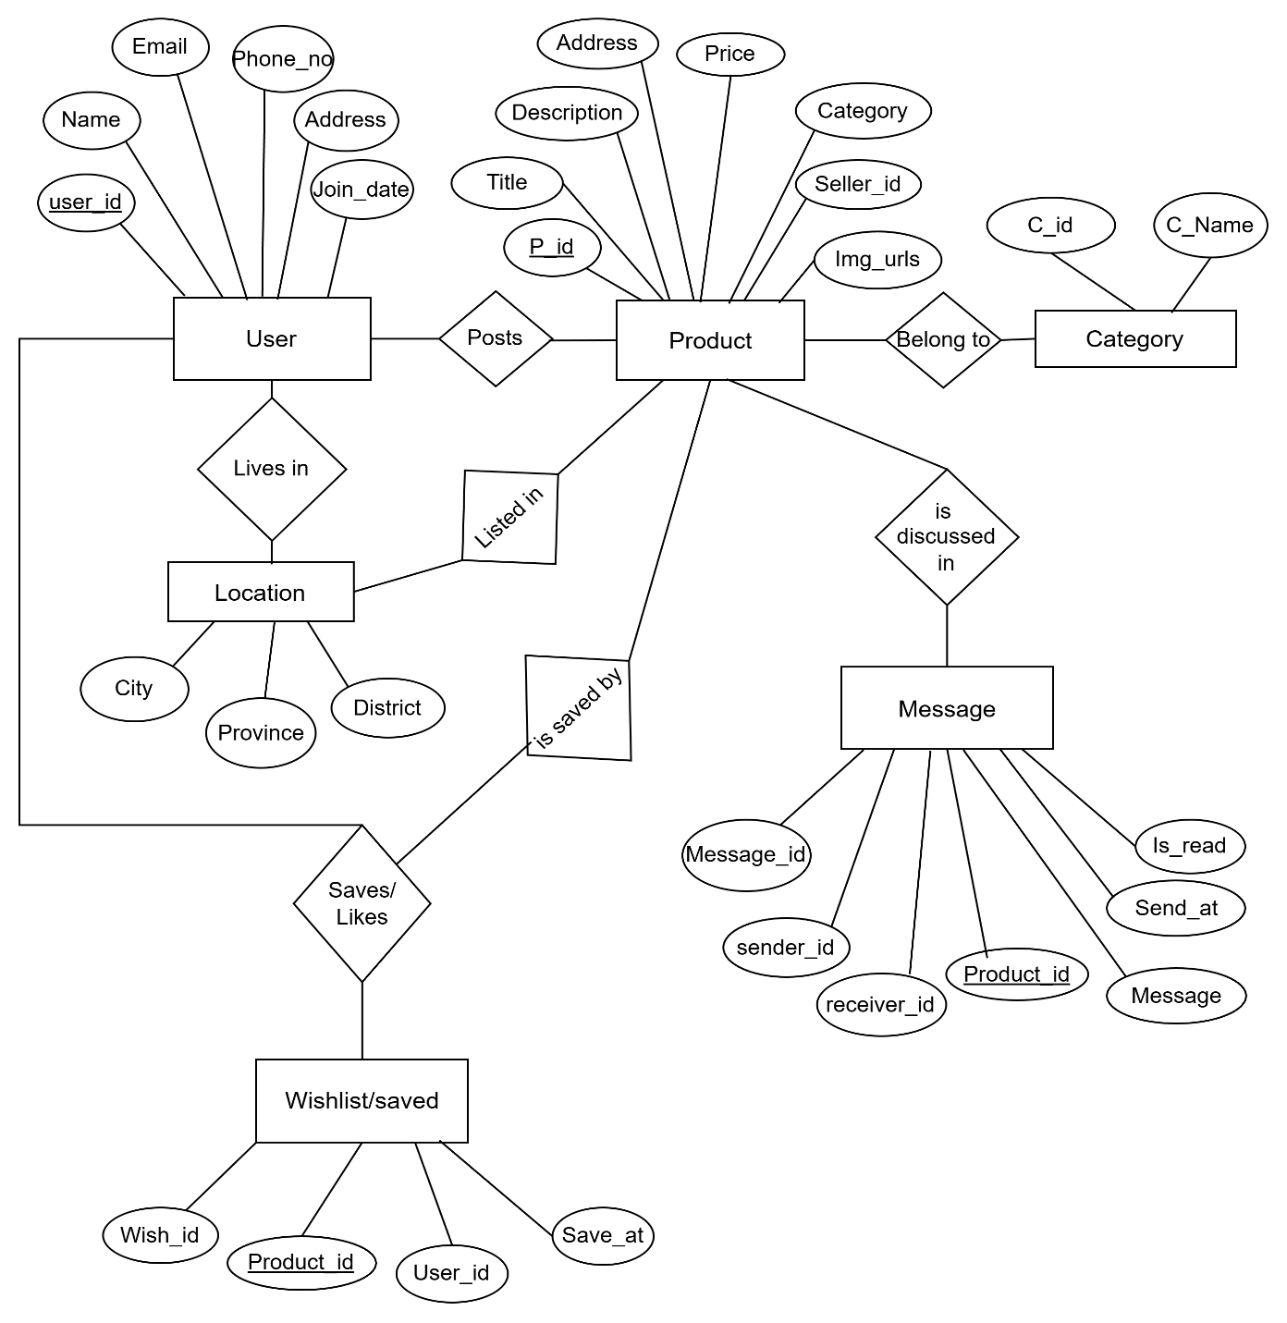Fig 3.2: Proposed ER Diagram for Dealmate

Flowchart
This flowchart represents the working process of an online product marketplace system. It begins with user login or registration, after which users can act as either sellers or buyers. Sellers verify their accounts, access the seller dashboard, create listings, add product images, and preview details before paying a listing fee to publish their product. Buyers, on the other hand, can browse or search for products, view product details, and chat with sellers. If interested, they can meet the seller, inspect the item, and proceed to buy it. After purchase, buyers can review the product and rate the seller, completing the transaction cycle.
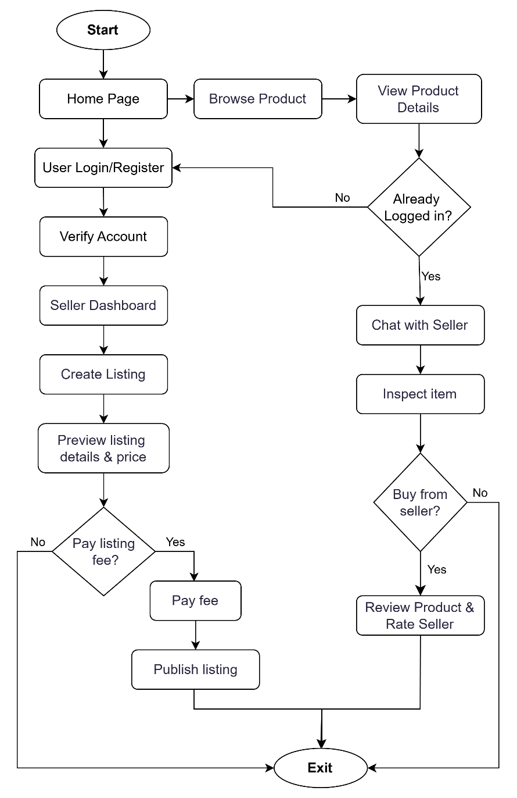
Fig 3.3: Flowchart for Dealmate

Use Case Diagram
The use case diagram shows an Online Marketplace System with three main actors: Buyer, Seller, and Admin. Buyers can register, browse and filter products, view details, chat with sellers, and leave reviews. Sellers can verify accounts, create and manage listings, add images, pay fees, and chat with buyers. Admins verify sellers, manage users, monitor ratings, resolve issues, and view reports. The diagram includes “include” and “extend” relationships to show dependencies between related actions.
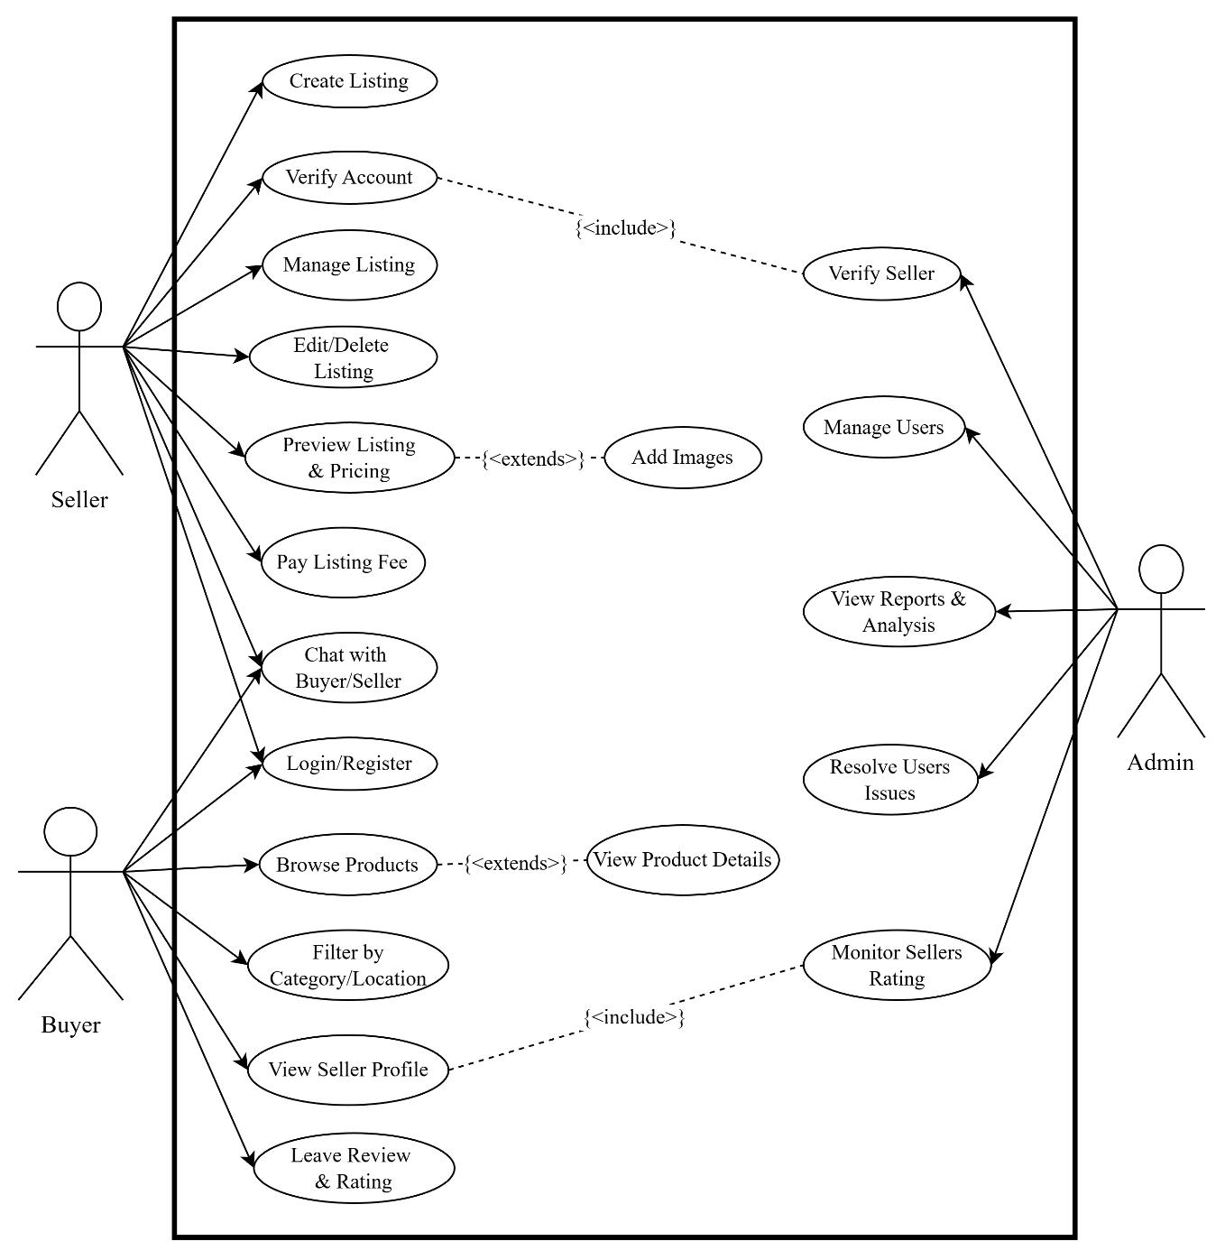
Fig 3.4: Use Case Diagram for Dealmate

Working Principles
- User Authentication
Users first register or log into the system using their email, username, or password. The backend checks whether the entered information is correct. Once verified, the credentials are stored securely in the database. This process ensures that only authorized users can access the platform and that user data remains safe.
- Seller Workflow
- Uploading Product Images.
The seller begins by uploading product photos to the system.
- Image Understanding Using Gemini
The uploaded images are processed by Gemini-1.5-flash, which analyzes the picture and extracts useful information such as: Object name, Brand text, Visible product details reduces the manual effort required from the seller.
- Category Prediction
Based on the extracted information, Gemini-1.5-flash predicts the correct product category.
This ensures that products are placed in the most relevant section.
Gemini uses probability distribution to predict categories.
Formula (Softmax Probability):
$$P(y_{i})=\frac{e^{z_{i}}}{\sum_{j=1}^{n}{}e^{z_{j}}}$$
- AI-Assisted Description Generation
Gemini helps generate: Product title, Descriptions, Key features. This makes product listing faster, clearer, and more consistent across the platform.
- Buyer Workflow
- Searching and Browsing
Buyers can browse products or use filters like category, price, and condition to find relevant items.
- AI-Based Ranking
The system uses AI to rank products and display the most relevant results first, improving search quality and user satisfaction.

- Communication
Once a buyer finds a product, they can chat with the seller through the built-in real-time chat system. Transactions are completed offline according to the agreement between buyer and seller.
- Recommendation System
The recommendation system is powered by scikit-learn and uses cosine similarity to compare product features. It identifies products that are similar to the one the buyer is viewing or searching for and recommends them. This helps buyers discover more options and improves the platform experience.
Cosine similarity is used to compare two products based on their feature vectors.
Formula:
$$\text{Cosine Similarity}=\frac{A⋅B}{∥A∥∥B∥}$$

- AI Chatbot
The AI Chatbot, powered by Gemini-1.5-flash, helps users by answering common questions such as:
- How to post a product
- How to search or use filters
- How to edit or delete a listing
- Guidelines for safe transactions
- General FAQs about the platform

CHAPTER 4

EPILOGUE

Expected Output
The project will result in a fully functional secondhand marketplace where sellers can list products and buyers can browse and communicate. AI features will categorize product images and generate titles and descriptions automatically. Sellers pay listing fees online, while buyers conduct purchases offline. The platform also supports chat and review systems, ensuring transparency and ease of use. Overall, it aims to simplify listing management, enhance user experience, and provide intelligent recommendations.

Budget Analysis
Table 4.1: Budget Analysis for Dealmate
Category | Descriptions | Estimated Cost (NPR)
Software Tools & Development Platforms | Node.js, React.js, MongoDB, VS Code, GitHub, Postman, required dev tools | 0
Cloud Hosting & Server Expenses | Microsoft Azure hosting for backend, frontend, and AI modules.By Azure for Students Credits. | 0
Domain & SSL Certificate | Domain registration (.com .io etc.) + SSL security certificate | 1,500
Payment Gateway Integration | Integration with Khalti/eSewa for listing fee transactions. | 1,000
Miscellaneous Expenses | Premium UI asset kits, icons, and testing tools. | 2,000
Total Estimated Budget |  | 4,500

Work Schedule
The project follows a structured workflow based on the Waterfall Model, consisting of sequential phases. The schedule below outlines the expected timeline for each major activity.


Fig 4.1: Gantt Chart

0
2
4
6
8
10
12
Documentation
Testing and Debugging
Coding
Designing
Familiarization of Tools
Research
weeks

REFERENCES
[1] M. Fowler, Patterns of Enterprise Application Architecture. Addison-Wesley, 2002. [Online]. Available: https://martinfowler.com/books/eaa.html. [Accessed: Nov. 25, 2025]
[2] R. Botsman and R. Rogers, What's Mine Is Yours: The Rise of Collaborative Consumption. Harper Business, 2010. [Online]. Available: https://www.harpercollins.com/
products/whats-mine-is-yours-rachel-botsmanroo-rogers. [Accessed: Nov. 25, 2025]
[3] K. C. Laudon and C. G. Traver, E-commerce: Business, Technology, Society, 16th ed. Pearson Education, 2020. [Online]. Available: https://books.google.com/books/about/
E_Commerce.html?id=MOZ-zQEACAAJ. [Accessed: Nov. 25, 2025]
[4] I. Goodfellow, Y. Bengio, and A. Courville, Deep Learning. MIT Press, 2016. [Online]. Available: https://mitpress.mit.edu/9780262035613/deep-learning/.[Accessed: Nov. 25, 2025]
[5] L. Zheng, Z. Tan, K. Han, and R. Mao, "Collaborative multi-modal deep learning for personalized product retrieval in Facebook marketplace," in Proc. IEEE Conference on Computer Vision and Pattern Recognition Workshops, 2018, pp. 1-8. [Online]. Available:
https://arxiv.org/abs/1805.12312. [Accessed: Nov. 25, 2025]
[6] L. Han, Z. Yin, Z. Xia, L. Guo, M. Tang, and R. Jin, "Vision-based price suggestion for online second-hand items," arXiv preprint arXiv:2012.06009, 2020. [Online]. Available:
https://arxiv.org/abs/2012.06009. [Accessed: Nov. 25, 2025]
[7] J. Kim, S. Park and H. Lee, "User Experience Challenges in Second-hand E-commerce Platforms," International Journal of Electronic Commerce, vol. 22, no. 3, pp. 345-362, 2018.[Online]. Available: https://www.tandfonline.com/doi/full/10.1080/10864415.2018.
1462925. [Accessed: Nov. 25, 2025]
[8] M.-H. Huang and R. T. Rust, "Artificial Intelligence in Service," Journal of Service Research, vol. 21, no. 2, pp. 155-172, 2018. [Online]. Available: https://journals
.sagepub.com/doi/10.1177/1094670517752459. [Accessed: Nov. 25, 2025]
[9] Y. Chen, L. Wang and Q. Zhang, "Deep Learning Based Recommendation System," in Proceedings of the 42nd International ACM SIGIR Conference, 2019, pp. 1053-1056. [Online]. Available: https://dl.acm.org/doi/10.1145/3331184.3331328. [Accessed: Nov. 25, 2025]
[10] F. Ricci, L. Rokach and B. Shapira, Recommender Systems Handbook, 2nd ed. Springer, 2015. [Online]. Available: https://link.springer.com/book/10.1007/978-1-4899-7637-6. [Accessed: Nov. 25, 2025]
[11] X. Wang, Y. Zhang and Z. Li, "Image-based Product Classification Using Deep Learning," IEEE Transactions on Multimedia, vol. 22, no. 12, pp. 3063-3075, 2020. [Online]. Available: https://ieeexplore.ieee.org/document/8946680. [Accessed: Nov. 25, 2025]
[12] P. A. Pavlou, "Consumer Acceptance of Electronic Commerce: Integrating Trust and Risk with the Technology Acceptance Model," International Journal of Electronic Commerce, vol. 7, no. 3, pp. 101-134, 2003. [Online]. Available: https://www.tandfonline
.com/doi/abs/10.1080/10864415.2003.11044275. [Accessed: Nov. 25, 2025]
[13] E. Turban, J. Outland, D. King, J. K. Lee, T.-P. Liang, and D. C. Turban, Electronic Commerce 2018: A Managerial and Social Networks Perspective. Springer, 2018. [Online]. Available: https://link.springer.com/book/10.1007/978-3-319-71685-2. [Access
ed: Nov. 25, 2025]

